Careers and Work-Related Experiences (CWRE) Policy

Careers Lead: Jeff Powell

Signed:
Date: November 2023
Date adopted:
Review date: November 2024

Contents
Contents | Page Number
Vision Statement | 2
Aims | 3
Statutory Requirements | 3
Benefits of CWRE | 3
Roles and Responsibilities | 4
Programme | 5
Skills through CWRE | 5
Work Related Experiences | 7
Additional CWRE Experiences | 7-9
Staffing | 9
ALN | 9
Professional Learning | 10
Assessing Impact | 10
Stakeholder and Employer/Business Links | 10
Links to other Policies | 10
Monitoring and Reviewing | 10

Vision Statement
Ysgol Bryn Elian aims to help all students fulfil their potential and experience success through an educational environment, which responds to individual needs and stimulates and challenges each and every student.
Careers Education is accorded a high priority, in preparing students for the opportunities and challenges of adult and working life. Careers Education plays an important role in motivating our students to maximise their academic and personal achievement whilst at the school.
Our vision is to create confident, ambitious, enterprising and creative learners who are able to successfully identify, research and pursue their future career options locally, nationally and internationally.

Aims
To support all learners to make progress, Ysgol Bryn Elian will embed and develop CWRE throughout Years 7 to 13 and across all curriculum areas. This policy aims to set out Ysgol Bryn Elians provision of impartial and informed careers guidance for our learners. This includes the ways in which learners, parents, teachers and employers can access information about our careers programme. High-quality careers guidance is important for our learners’ futures, and our CWRE provision aims to:
- Develop learner’s awareness of future education, training and careers opportunities, based on an accurate assessment of their own abilities and aptitudes.
- Develop a clear and up to date understanding of the world of work.
- Enable learners to prepare for the workplace, by developing work place skills and career management skills.
- Enable learners to understand the career pathways that they’re interested in, and to make informed decisions about their next career step by providing independent and impartial careers advice and guidance.
- Promote a culture of high aspirations and equality of opportunity.
- Develop skills to form and implement effective decision making and a reflective approach to learning from experience.

Statutory Requirements

Learning about CWRE is fundamental to developing skills for work and life. This helps learners to understand the relationship between their learning and the world of work.
A school’s curriculum should enable learners to gain experiences related to work and careers, developing knowledge of the breadth of opportunities available to them throughout their lives. This learning can help them make informed decisions about their career pathways.
Effective CWRE is comprised of age and developmentally appropriate careers education embedded across the six Areas of Learning and Experiences(AoLE’s). It is supported by a wide range of relevant work-related learning experiences and environments. To help ensure that learners are engaged in CWRE, schools or settings should have regard to a range of factors such as learners’ age, knowledge and additional learning needs.

Benefits of CWRE at Ysgol Bryn Elian
CWRE enables learners to develop their knowledge, skills and understanding in preparation for the challenges and opportunities of further learning and the ever-evolving world of work. CWRE contributes towards learners’ realisation of the four purposes of the Curriculum for Wales.
From the age of 3, CWRE should inspire learners to:
- develop an understanding of the purpose of work in life, both for themselves and for society as a whole.
- become increasingly aware of the range of opportunities available to them, broadening their horizons.
- develop the attitudes and behaviours required to overcome barriers to employability, career management and lifelong learning.
- appreciate the increasing range of opportunities in the workplace where an ability to communicate in Welsh is important.
- explore opportunities through a variety of meaningful experiences in learning, work and entrepreneurship.
- develop resilience and the ability to be adaptable in response to the challenges, choices and responsibilities of work and life.

Roles and Responsibilities
Careers Lead
The careers lead at Ysgol Bryn Elian is Mr Jeff Powell and they can be contacted by phoning 01492 518215 (Ext 216) or emailing powellj190@ysgolbrynelian.cymru
Our careers leader will:
- Take responsibility for developing, running and reporting on the school’s career programme.
- Plan and manage careers activities.
- Support teachers to build careers education and guidance into subjects across the curriculum.
- Establish and develop links with employers, education and training providers, and careers organisations (Careers Wales).
- Work closely with relevant staff, including our special educational needs co-ordinator (SENCO), Learning Managers and careers adviser, to identify the guidance needs of all of our pupils.

Careers Advisor
At the forefront of our delivery is our professionally trained careers adviser (Ariane Tomes). Careers Wales’ professional standards for advisers require them to achieve QCF Level 6 in Career Guidance and Development or the equivalent and register with the Career Development Institute’s (CDI) UK Register of Career Development Professionals. They provide impartial and professional support to individuals and co-ordinate the range of services of the Careers Wales team for individual schools.
The service offer that is provided by Careers Wales will focus on short and long term needs of learners with a focus on:
- Broadening horizons.
- Raising awareness of the skills required in the modern labour market.
- Development of the skills for career planning both short and long term support at key transition points for pupils who need it.

Our work in Key Stage 4 will offer all learners support which will be differentiated to meet their individual need. With pupils allocated to one of four categories of support thus ensuring that our resources are deployed in line with customer need:
- Universal support for those young people who will self-help through our digital and social media platforms and attend group sessions.
- Career Check support - one to one support for those young people identified as in need of guidance and coaching support.
- Targeted support for those young people whose characteristics can lead to them being underrepresented in Education, Employment or Training in post compulsory education.
- Additional Learning Needs Support - one to one support for those young people identified as having additional learning needs (ALN) See page below for more specific detail.

The Governing Body
- Provide clear advice and guidance on which the school can base a strategic careers plan which meets legal and contractual requirements.
- Appoint a member of the governing board who will take a strategic interest in careers education and encourage employer engagement.
- Make sure independent careers guidance is provided to all pupils throughout their secondary education (11 to 18 year-olds) and that the information is presented impartially, includes a range of educational or training options and promotes the best interests of pupils.
- Make sure that a range of education and training providers can access pupils in years 7 to 13 to inform them of approved technical education qualifications and apprenticeships.
- Make sure that details of our school’s careers programme and the name of the careers leader are published on the school’s website.
- Make sure that arrangements are in place for the school to meet the statutory requirements for delivery of CWRE at Ysgol Bryn Elian.

The Programme
Whole School Approach
CWRE will be delivered across the curriculum for learners to explore and understand the world of work in developmentally appropriate contexts. CWRE provides real-world learning and experiences that support learners in developing their skills and applying their knowledge and understanding within all the Areas. In doing so, CWRE supports the design of a purposeful curriculum and opportunities for authentic learning which is vital to learners’ increasing understanding of their career choices as they progress.
It will be the responsibility of the Heads of Departments and teaching staff to plan in CWRE into their Mid-Term Plans. If employer engagement support is required, teachers will need to contact Martin Webber (martin.webber@careerswales.gov.wales). Guidance on how CWRE supports learning within each Area can be found in the respective sections of this guidance below (Hyperlinked to each AoLE):
- Expressive arts
- Health and well-being
- Humanities
- Languages, literacy and communication
- Mathematics and numeracy
- Science and technology

Skills through CWRE
Ysgol Bryn Elian will help learners to begin to appreciate the importance of using skills integral to the four purposes within careers and work-related experiences. Ysgol Bryn Elian will encourage learners’ evolving perception of their potential contribution to the future world of work. This learning will progress to enable them to appreciate how their contributions can benefit not only themselves but also the future prosperity of their communities, Wales and the wider world.
Skills integral to the four purposes
- Creativity and innovation
Through being actively engaged in real-life examples from the world of work, learners can develop their confidence to be more curious and inquisitive. This enables learners to begin to consider, investigate and generate novel solutions to problems, which can provide opportunities to develop an entrepreneurial mind-set. Skills that contribute to individuals becoming creative and innovative are increasingly valued by employers across sectors, as they can support advancements and the continuous improvement of efficiency and effectiveness in industry.
- Critical thinking and problem-solving
As learners begin to develop their critical thinking and problem-solving skills, CWRE contexts can be used to encourage risk-taking. Applying these skills to their own career pathway supports learners to better understand the correlation between risk and reward, and how this impacts on their experience of the world of work. Learners should critically analyse a diverse range of information to shape their views and perspectives on the world of work. This will support them to understand and consider the impact of their decisions, now and on future generations.
- Personal effectiveness
Learners’ growing self-awareness and confidence contributes to their appreciation of their self-worth and how this relates to what they have to offer to the world of work. Employers value skills such as contributing to a team, leadership, resilience and the ability to reflect, adapt and change in different situations. As learners progress, they should increasingly reflect on their effectiveness during and after careers and work-related experiences, enabling them to identify strengths and areas for further training and development. Developing an enquiring mind-set encourages learners to be open to acquiring new skills. This can support learners in becoming more adaptable which will enable them to access further opportunities in the world of work.
- Planning and organising
Experiencing these skills in authentic contexts can help develop learners' decision-making and reflective-thinking skills. CWRE allows learners to demonstrate their planning and organising skills, such as implementing ideas, setting goals, time management and monitoring and reflecting on results. Learners can be encouraged to become increasingly independent, which will support them in taking greater responsibility for their development in work and study. Planning and organising skills are highly valued by employers, and learners need to be supported to understand the relevance of these skills so that they can achieve their ambitions.
Cross-curricular skills
Ysgol Bryn Elian will help learners to begin to appreciate the importance of using their cross-curricular skills within careers and work-related experiences.
- Literacy
The world of work requires the ability to communicate effectively and apply literacy skills in different contexts. Developing effective communication skills enables learners to engage in careers and work-related experiences, for example, when considering other people’s views and opinions. This will help learners understand the importance of developing positive relationships in the world of work.

- Numeracy
The world of work requires the ability to use numeracy effectively. Learners need to develop confidence in applying their numeracy skills, for example, when using and interpreting data and understand the importance of managing money in work and life. Learners, as they progress with their numeracy skills, should have opportunities to apply knowledge within different CWRE contexts.
- Digital Competence
Increasingly, the world of work requires the ability to use digital technology in a wide range of situations. With an ever-evolving and international world of work, learners need to develop their digital confidence and capability, which will enhance their communication skills, as well as be able to access CWRE opportunities and analyse information from beyond their own locality.
A learner’s digital footprint can be long-lasting and affect their career prospects, both positively and negatively. Learners should be encouraged to question the validity and accuracy of the information found on digital platforms when considering their life choices.
Work Related Experiences
Work experience opportunities support learners to develop future career aspirations. These will take many forms depending on the local labour market. Work-related experiences encompass a range of activities including employer visits, masterclasses and mentoring structured work as well as enterprise experiences, taster sessions and careers events.
At Ysgol Bryn Elian the following Work Related Experiences take place:
- Careers Fair
- Work Experience (for specific students)
- Guest Speakers
- Y12 Global Community Project
- University/Apprenticeships Taster sessions
Long-term and sustained employer engagement has the potential to inspire and enhance learners’ understanding of the world of work. It is important that work-related experiences are broad, varied and developmentally appropriate. Learners should develop an understanding that the world of work is more than just paid employment.

Additional CWRE Experiences
Our careers programme at YBE is also delivered through a number of other methods, including: Displays, Guest Speakers, Tutor Led Sessions, The Careers Wales Programme and Assemblies.
Brighter Futures Partnership Offer
Careers Wales delivers a remit set by Welsh Ministers which provides the all-age, independent, impartial and bilingual guidance and coaching service as well as Careers and Work Related experiences (CWRE) service in Wales.

The intention within the Brighter Futures Vision is to:
- Start supporting young people earlier through providing curriculum support and training to teachers in primary schools;
- Provide more tailored and personalised support and information to young people, parents/ carers and to schools through our ambitious digital vision; and learning and work develop our work with employers, training providers and entrepreneurs to better understand the skills requirements of the future workforce and to bring greater connectively between young people and employers.

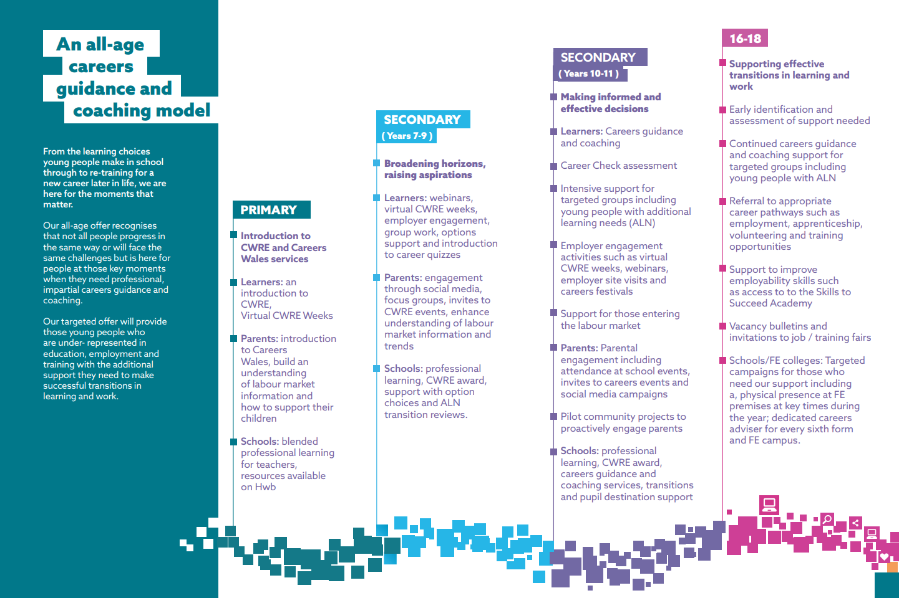
For further information relating to the Brighter Futures Service Offer please refer to the Ysgol Bryn Elian and Careers Wales Partnership agreement.

Career Programmes & Activities
Year Group | Examples of Careers Activities
7 | Careers Specific Assemblies  Careers Fair  Career Subject Specific Information within Mid Term Plans
8 | Careers Specific Assemblies  Careers Fair  Career Subject Specific Information within Mid Term Plans
9 | Careers Specific Assemblies  Careers Fair  Year 9 Options Information  Career Subject Specific Information within Mid Term Plans  Careers Specific Lessons within PSE  Targeted Careers Interviews  Careers advisor attends Parent evenings
10 | Careers Specific Assemblies  Careers Fair  Career Check Survey  Careers Specific Lessons – Information Pathways and Signposting  Welsh Baccalaureate (Enterprise Challenge- Dragons Liar, Community Volunteering, Outside Speakers)
11 | Careers Specific Assemblies  Post 16 Options Assemblies  Careers Fairs  Year 11 Options Information  Careers Interviews  Teams Apprenticeships  Targeted Parents Evening  Careers advisor attends Parent evenings  Welsh Baccalaureate (Future Destinations)
12/13 | Careers Specific Assemblies  Post 18 Options Assemblies  Careers Fair  Careers Interviews  UCAS/Finance Talks  Teams Apprenticeships  Welsh Baccalaureate (Global Community Project, Future Destinations, Practice Interviews and Presentations)

Staffing
All staff are expected to contribute to CWRE delivery through their roles as tutors, subject teachers and support staff. Specialist careers education sessions are delivered by form tutors in registration periods. The CWRE programme is planned, monitored and evaluated by the career’s coordinator, Heads of Department and teaching staff.
Pupils with Additional Learning Needs (ALN)
We expect that the majority of learners with ALN will follow the same careers programme, with adjustments and additional support as needed.

Our careers leader will work with teachers and, where appropriate, professionals from relevant organisations, to identify the needs of our pupils with ALN and put in place personalised support and transition plans. This may include meetings with pupils and their families to discuss education, training and employment opportunities, supported internships and transition plans into higher education.

Professional learning
Ysgol Bryn Elian ensure their staff engage in appropriate and relevant professional learning opportunities to help CWRE become effectively integrated in their curriculum. Practitioners are also encouraged to undertake training opportunities offered by employers and other organisations, to help them learn about the latest developments in the world of work. For example, they could explore resources that are available on Hwb, as well as engage with Careers Wales, regional consortia and learning modules available online. Courses are also available for those who wish to obtain a professional careers-related qualification. The school is committed to allocating sufficient resources for CWRE and ensuring that these resources are effectively deployed.

Assessing the impact on pupils
Our career programme is designed so pupils can give feedback, and their progress measured as they move through the Progression Steps. We measure and assess the impact of the programme’s initiatives by:
- Learner Voice.
- Surveys completed by learners, parents, teachers and employees.
- Evaluations.

Stakeholders and Employers/Business Links:
- At Ysgol Bryn Elian we are committed to working with key stakeholders such as employers, Careers Wales, local learning providers, Higher Education Institutions etc.
- On an annually basis our Partnership Agreement with Careers Wales is reviewed and agreed for the following year.
- At Ysgol Bryn Elian we recognise the important role that parents/carers have in their child’s career development. We will keep parents/carers informed with relevant careers information, specifically around options and transition from Year 11/13 through a range of platforms, including emails, Satchel One, Facebook and our website.
- Employer / business links will be developed, coordinated and maintained through partnership working and established links with Career Wales.

Links to other Policies
This policy links to the following policies
- Child Protection Policy
- Teaching and Learning Policy
- Equal Opportunities Policy
- ALN Policy

Monitoring and Reviewing

This policy, the information included, and its implementation will be monitored by the governing body and reviewed annually. The next review date is November 2024.

